Assignment 1
Software Enginneering
Tyler Wilding

Source Code
Bowling.java
import java.util.Scanner;
import java.util.regex.Matcher;
import java.util.regex.Pattern;
/**
* Author - Tyler Wilding
* Program - Bowling Score
* Description - Keeps track of the players score while playing 10 pin bowling.
*/
public class Bowling {
//Variables
public static int[] frameScore;
public static int[] bonusCount;
public static int[] pins;
public static int frameNumber;
public static int throwCounter;
public static boolean finalFrame;
/**
* Bowling Construction, resets the variables for the bowling object.
*/
public Bowling() {
frameScore = new int[10];
bonusCount = new int[10];
pins = new int[21];
throwCounter = 0;
finalFrame = false;
frameNumber = 0;
}
/**
* Main method that runs through 10 frame inputs with a scanner.
* @param args Command line arguments not used.
*/
public static void main(String[] args) {
Scanner scan = new Scanner(System.in);
while(frameNumber < 9) { //Loop 9 times for 9 frames, 10th time is outside the loop as it is slightly different.
frame(scan.next(), scan.next(), null);
}
frame(scan.next(), scan.next(), scan.next());
System.out.println(totalScore());
}
/**
* Accepts one input for the frame, would be used for a strike for example.
* @param pinsOne First throw's details.
*/
public static void bowl(String pinsOne) {
frame(pinsOne, "0", null);
}
/**
* Accepts two inputs for the frame, can be used for normal hits or a spare.
* @param pinsOne First throw's details
* @param pinsTwo Second throw's details
*/
public static void bowl(String pinsOne, String pinsTwo) {
frame(pinsOne, pinsTwo, null);
}
/**
* Accepts three inputs for the frame, used for the final frame, where a bonus throw is possible.
* @param pinsOne First throw's details
* @param pinsTwo Second throw's details
* @param pinsThree Third throw's details
*/
public static void bowl(String pinsOne, String pinsTwo, String pinsThree) {
frame(pinsOne, pinsTwo, pinsThree);
}
/**
* Processes the frame's input to enter into the datastructures
* @param pinsOne First throw's details
* @param pinsTwo Second throw's details
* @param bonusMove Bonus throw's details
*/
public static void frame(String pinsOne, String pinsTwo, String bonusMove) {
//Variable is used to keep track of the previous shot's pin count, calculate for spare.
int previousShot = 0;
if(!checkUserInput(pinsOne)) //Verify user input
return;
int testKnocked = Integer.parseInt(pinsOne);
if(!updateScore(testKnocked, 0, throwCounter)) //Update score, will also verify if it was a valid input.
return;
//Update array, print score as of so far
pins[throwCounter++] = testKnocked;
previousShot = testKnocked;
printScore();
if(frameNumber == 9) //If we are on the last frame, use the marker variable.
finalFrame = true;
if(testKnocked == 10 && !finalFrame) { //If we hit a strike not on the final frame, skip the second input.
frameNumber++;
throwCounter++;
return;
}
//Repeat for the second throw
if(!checkUserInput(pinsTwo))
return;
testKnocked = Integer.parseInt(pinsTwo);
if(!updateScore(testKnocked, previousShot, throwCounter))
return;
pins[throwCounter++] = testKnocked;
previousShot = testKnocked;
printScore();
if(finalFrame) { //If we are on the final frame, it is a special case
if(pins[18] + pins[19] == 10) //If we hit a spare, mark it so.
bonusCount[9] = 1;
if(bonusCount[9] == 1 || bonusCount[9] == 2) { //If we hit a spare or a strike, we get an extra throw.
if(!checkUserInput(bonusMove))
return;
testKnocked = Integer.parseInt(bonusMove);
if(!updateScore(testKnocked, 0, throwCounter))
return;
pins[throwCounter++] = testKnocked;
printScore();
}
}
//Move to the next frame.
frameNumber++;
}
/**
* Computes the total score from all of the frames.
* @return The total score as of so far.
*/
public static int totalScore() {
int totalScore = 0;
for(int i = 0; i < frameScore.length; i++) {
totalScore += frameScore[i];
}
return totalScore;
}
/**
* Computes the runningTotal up to the current frame to be output at that frame.
* @param length How many frames to add up.
* @return Total up to that frame
*/
public static int runningTotal(int length) {
int runningTotal = 0;
for(int i = 0; i <= length; i++)
runningTotal += frameScore[i];
return runningTotal;
}
/**
* Update score method that checks if the throw input is valid, and deals with spares and strikes.
* @param knocked The amount of pins knocked down.
* @param previousShot The amount of pins knocked down in the previous shot.
* @param throwCounter What throw out of 21 is it.
* @return Will return -1 if error.
*/
public static boolean updateScore(int knocked, int previousShot, int throwCounter) {
if(frameNumber != 9 && previousShot + knocked > 10) { //If we are not on the final frame, and we hit more than 10, wrong.
System.out.println("Cant hit more than 10 points in a frame");
return false;
}
if(!finalFrame && knocked == 10) //Strike
bonusCount[frameNumber] = 2;
else if(!finalFrame && previousShot + knocked == 10) //Spare
bonusCount[frameNumber] = 1;
for(int i = 0; i < frameNumber; i++) { //Iterate through bonus array, consecutive throws will add to the previous frames.
if(bonusCount[i] > 0) {
bonusCount[i]--;
frameScore[i] += knocked;
}
}
//Add the pins knocked down to the score card.
frameScore[frameNumber] += knocked;
return true;
}
/**
* Print scorecard method, loops through and prints.
*/
public static void printScore() {
System.out.println();
int throwCounter = 0;
for(int i = 0; i < frameNumber; i++){
System.out.print("| "+runningTotal(i)+" |"+pins[throwCounter++]+"|"+pins[throwCounter++]+"|");
}
System.out.print("| "+runningTotal(9)+" |"+pins[throwCounter++]+"|"+pins[throwCounter++]+"|"+pins[throwCounter++]+"||");
System.out.println();
}
/**
* Check user input to see if it is not a letter or more than 10.
* @param input Users input as a string.
* @return True or False
*/
public static boolean checkUserInput(String input) {
//Define pattern, everything that is not 0-9
Pattern p = Pattern.compile("[^0-9]");
Matcher m = p.matcher(input);
if(m.find()) { //If the input contains anything besides 0-9, false.
System.out.println("Only enter numeric values!");
return false;
}
//If the input is a number but less than 0 or greater than 10, remove.
if(Integer.parseInt(input) > 10 || Integer.parseInt(input) < 0) {
System.out.println("Only accepts values between 0 and 10, inclusive!");
return false;
}
return true;
}
}

BowlingTest.java
import org.junit.Test;
import static org.junit.Assert.*;
/**
* Author - Tyler Wilding
* Description - Test class for bowling program.
*/
public class BowlingTest {
@Test
public void invalidRange() throws Exception {
Bowling test = new Bowling();
System.out.println("Testing Range!");
assertEquals(false, test.checkUserInput("15"));
assertEquals(false, test.checkUserInput("-15"));
System.out.println();
}
@Test
public void letters() throws Exception {
Bowling test = new Bowling();
System.out.println("Testing letter inputs!");
assertEquals(false, test.checkUserInput("a"));
assertEquals(false, test.checkUserInput("1a"));
assertEquals(false, test.checkUserInput("a1"));
System.out.println();
}
@Test
public void score() throws Exception {
Bowling test = new Bowling();
System.out.println("Testing Score");
assertEquals(true, test.updateScore(5, 0, 1));
assertEquals(false, test.updateScore(6, 5, 1));
}
@Test
public void perfectGame() throws Exception {
System.out.println("Perfect Score");
Bowling test = new Bowling();
for(int i = 0; i < 9; i++)
test.bowl("10");
test.bowl("10","10","10");
assertEquals(300, test.totalScore());
}
@Test
public void allThree() throws Exception {
System.out.println("All Three");
Bowling test = new Bowling();
for(int i = 0; i < 10; i++)
test.bowl("3", "3");
assertEquals(60, test.totalScore());
}
@Test
public void oneSpare() throws Exception {
System.out.println("One Spare");
Bowling test = new Bowling();
for(int i = 0; i < 10; i++) {
if(i == 4)
test.bowl("4", "6");
else
test.bowl("3", "3");
}
assertEquals(67, test.totalScore());
}
@Test
public void twoSpare() throws Exception {
System.out.println("Two Spares");
Bowling test = new Bowling();
for(int i = 0; i < 10; i++) {
if(i == 4 || i == 5)
test.bowl("4", "6");
else
test.bowl("3", "3");
}
assertEquals(75, test.totalScore());
}
@Test
public void oneStrike() throws Exception {
System.out.println("One Strike");
Bowling test = new Bowling();
for(int i = 0; i < 10; i++) {
if(i == 4)
test.bowl("10");
else
test.bowl("3", "3");
}
assertEquals(70, test.totalScore());
}
@Test
public void twoStrikes() throws Exception {
System.out.println("Two Strikes");
Bowling test = new Bowling();
for(int i = 0; i < 10; i++) {
if(i == 4 || i == 5)
test.bowl("10");
else
test.bowl("3", "3");
}
assertEquals(87, test.totalScore());
}
@Test
public void oneStrikeTenth() throws Exception {
System.out.println("One Strike in Tenth");
Bowling test = new Bowling();
for(int i = 0; i < 9; i++)
test.bowl("3", "3");
test.bowl("10","3","3");
assertEquals(70, test.totalScore());
}
@Test
public void threeStrikeTenth() throws Exception {
System.out.println("Three Strikes in Tenth");
Bowling test = new Bowling();
for(int i = 0; i < 9; i++)
test.bowl("3", "3");
test.bowl("10","10","10");
assertEquals(84, test.totalScore());
}
@Test
public void allSpares() throws Exception {
System.out.println("One Spare in Tenth");
Bowling test = new Bowling();
for(int i = 0; i < 9; i++) {
test.bowl("3","7");
}
test.bowl("3","7","3");
assertEquals(130, test.totalScore());
}
}

Screenshots
simple game with two continued strikes in the middle and others are 3 pins down, total score is 87
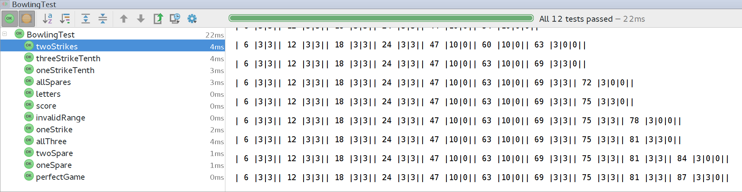
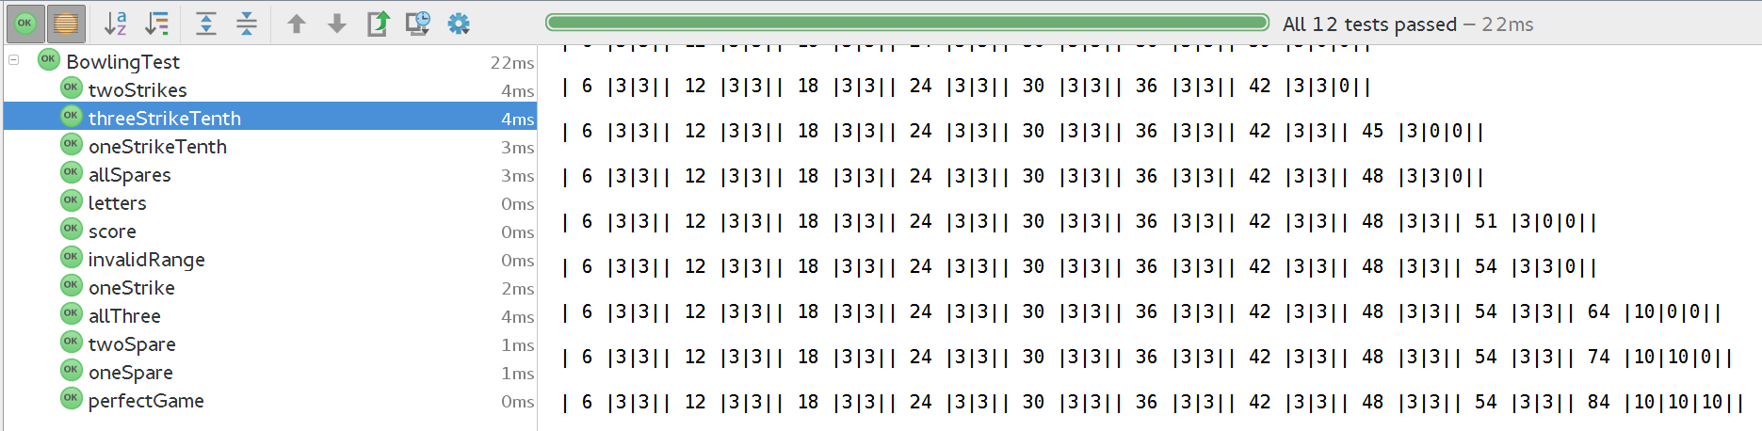
simple game with one strike in the tenth frame, each bonus is 10 and others are 3 pins down, total score is 84

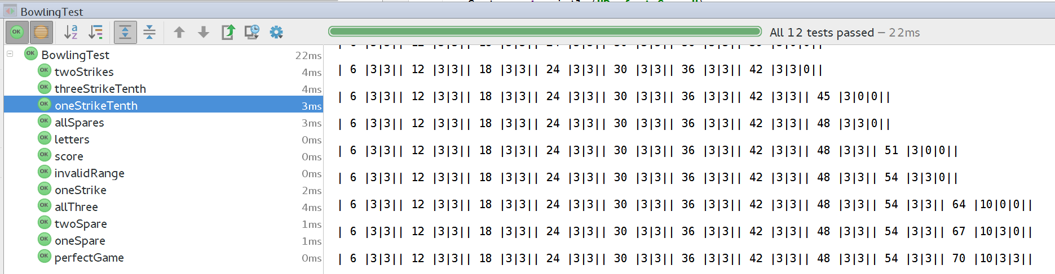
simple game with one **strike** in the tenth frame, bonus is 10, and others are 3 pins down, total score is 70 (tenth frame is 10, then 3, then 3)

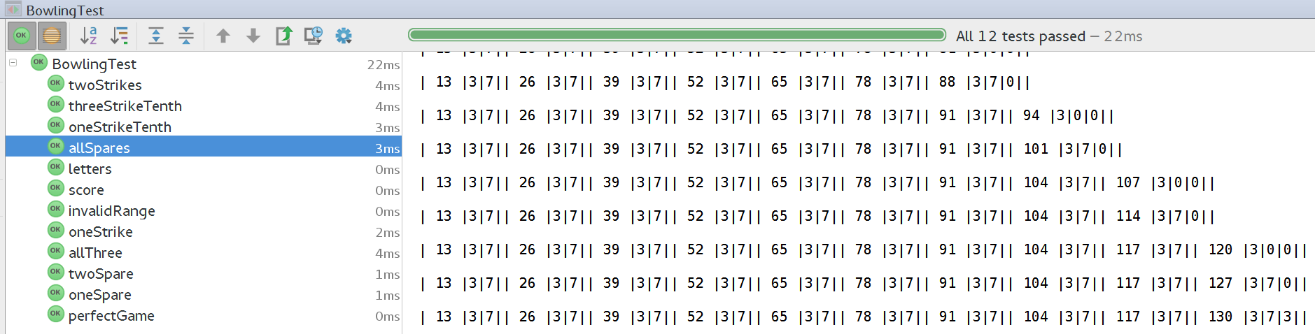
a game with all spare (3/7) total score is 130

with two throws in the same frame bigger than 10
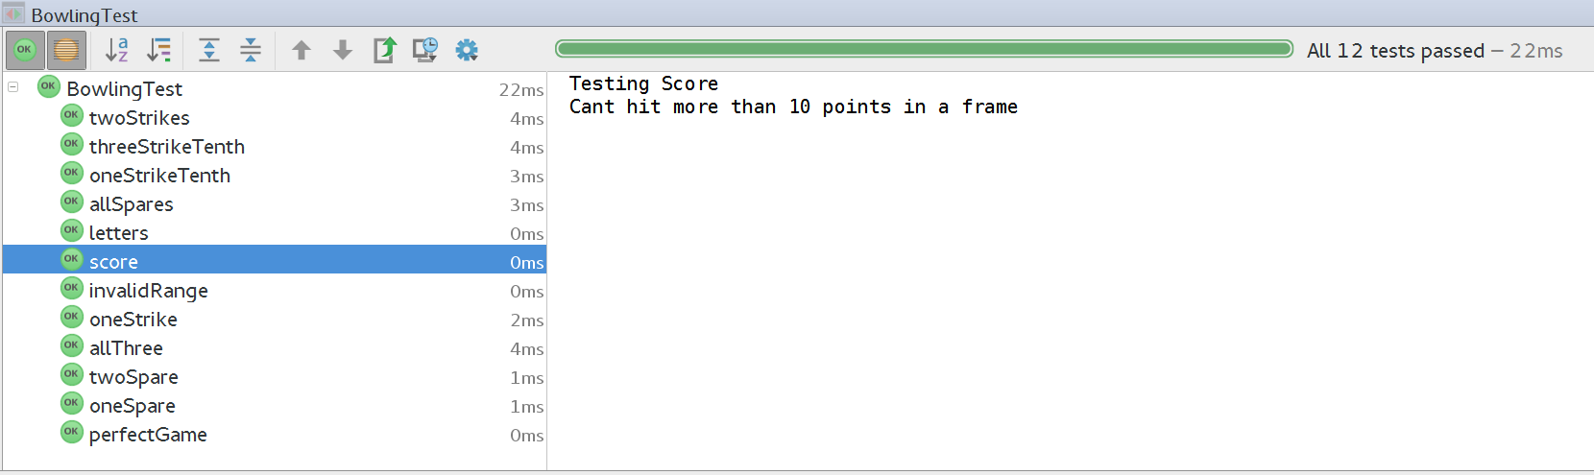
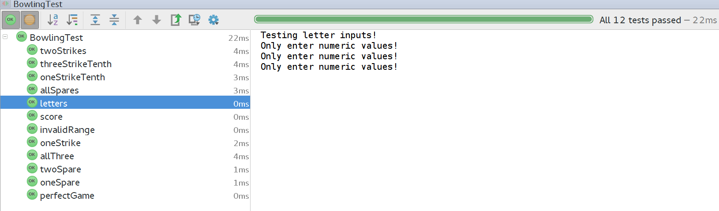
with letter input

with 15 for one throw

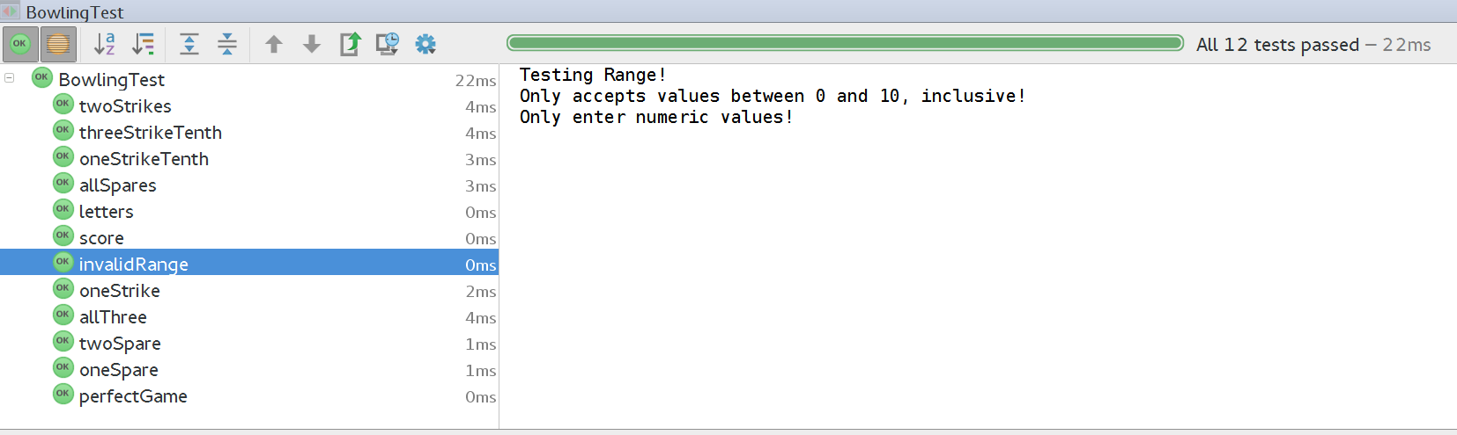
simple game with one strike in the middle and others are 3 pins down, total score is 70
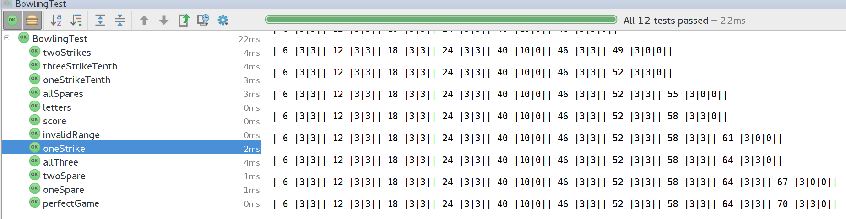

simple game with all throw with 3 pins down, total score is 60
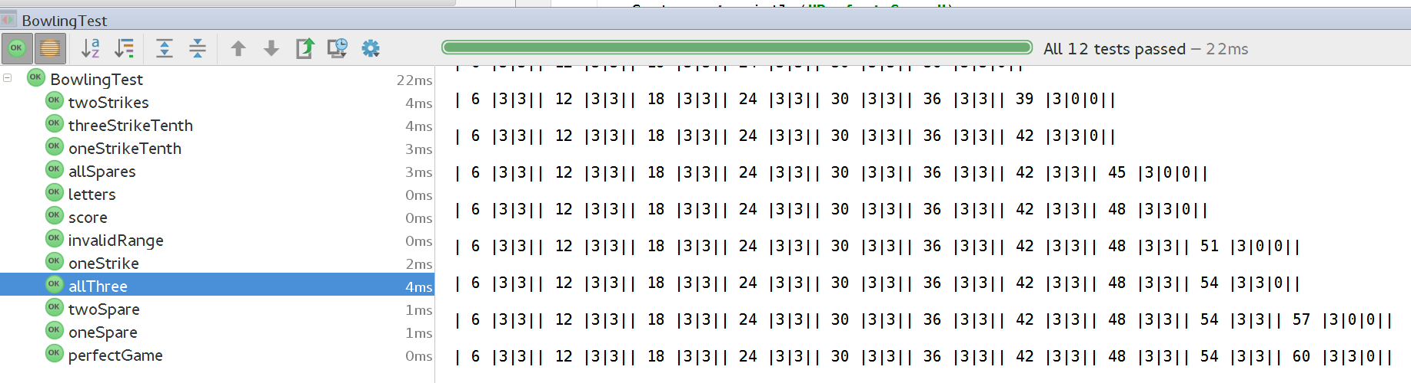
simple game with two continued spares (4/6) in the middle and others are 3 pins down, total score is 75
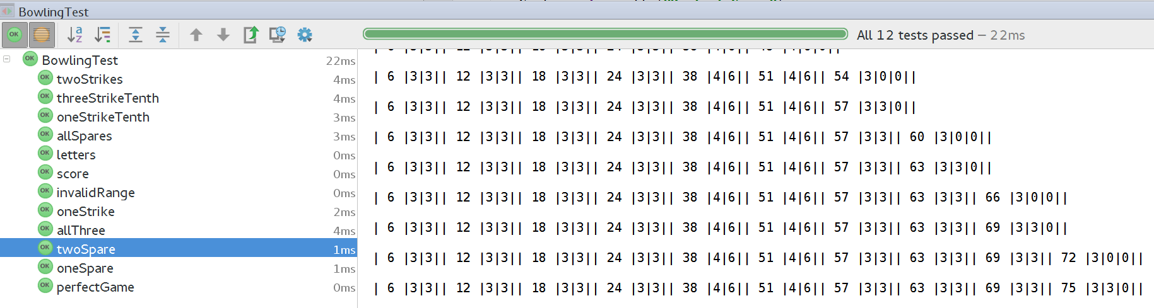
simple game with one spare (4/6) in the middle, and others are 3 pins down, total score is 67

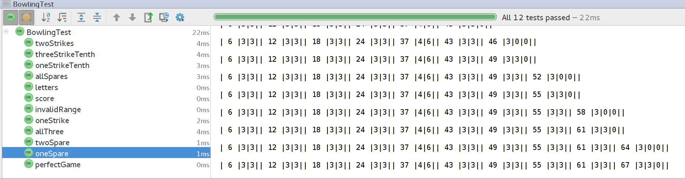
perfect game with all strike, total score is 300
